Nacos包源

<PackageReference Include="nacos-sdk-csharp" Version="1.3.5" />

<PackageReference Include="nacos-sdk-csharp.AspNetCore" Version="1.3.5" />

<PackageReference Include="nacos-sdk-csharp.Extensions.Configuration" Version="1.3.5" />

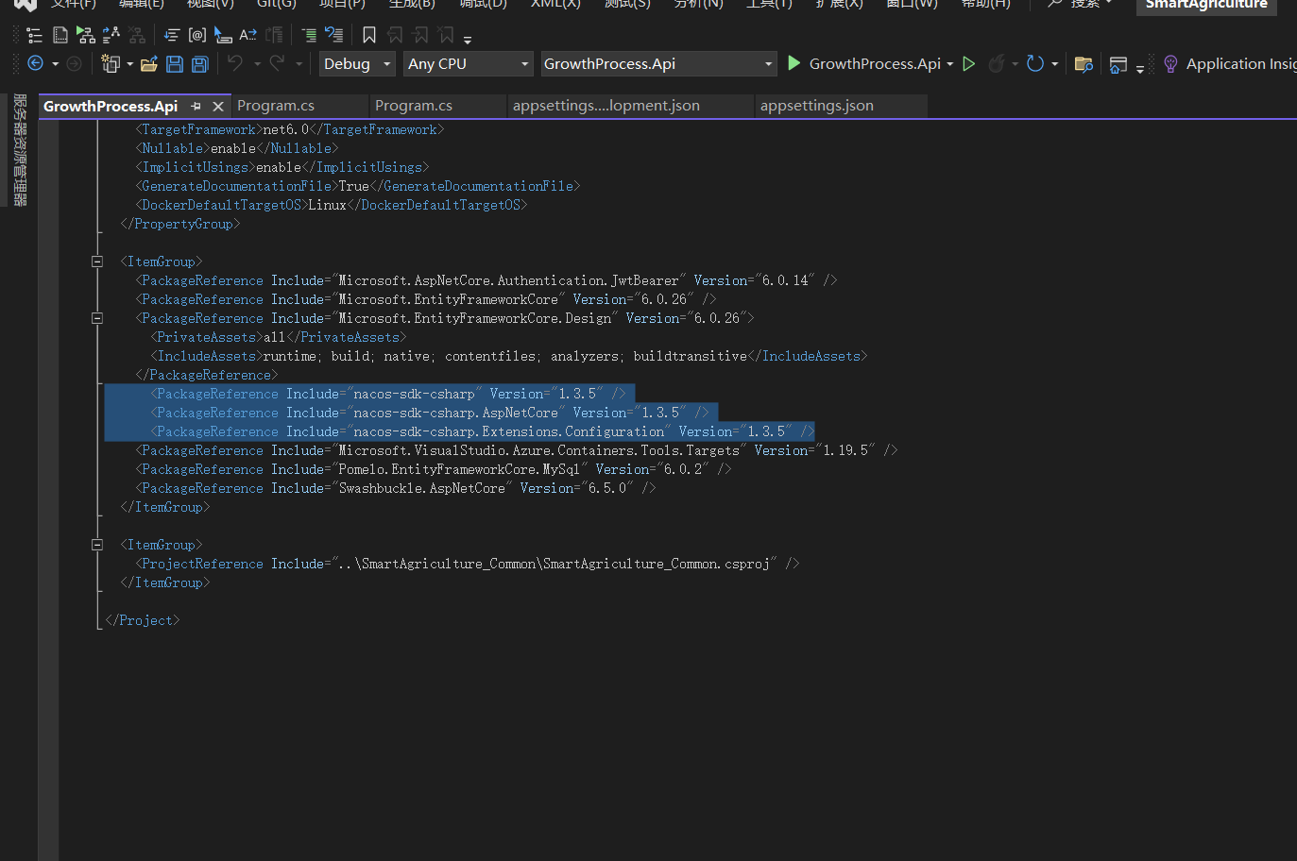

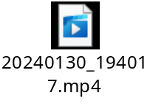
上面视频是介绍的是另一种引用nuget包方式.

"NacosConfig": {
"Listeners": [
{
"Optional": false,
"DataId": "RTY",//线上配置的id
"Group": "GrRTY"//线上配置的分组
}
],
"Namespace": "", // Please set the value of Namespace ID !!!!!!!!
"ServerAddresses": [ "http://10.31.56.14:8848/nacos" ],//要去哪里请求naocs配置的地址
"UserName": "",//
"Password": "",//新版本不用账号密码
"AccessKey": "",
"SecretKey": "",
"EndPoint": "",
"ConfigUseRpc": false,
"NamingUseRpc": false,
"ConfigFilterAssemblies": [ "" ],
"ConfigFilterExtInfo": "some ext infomation"
}

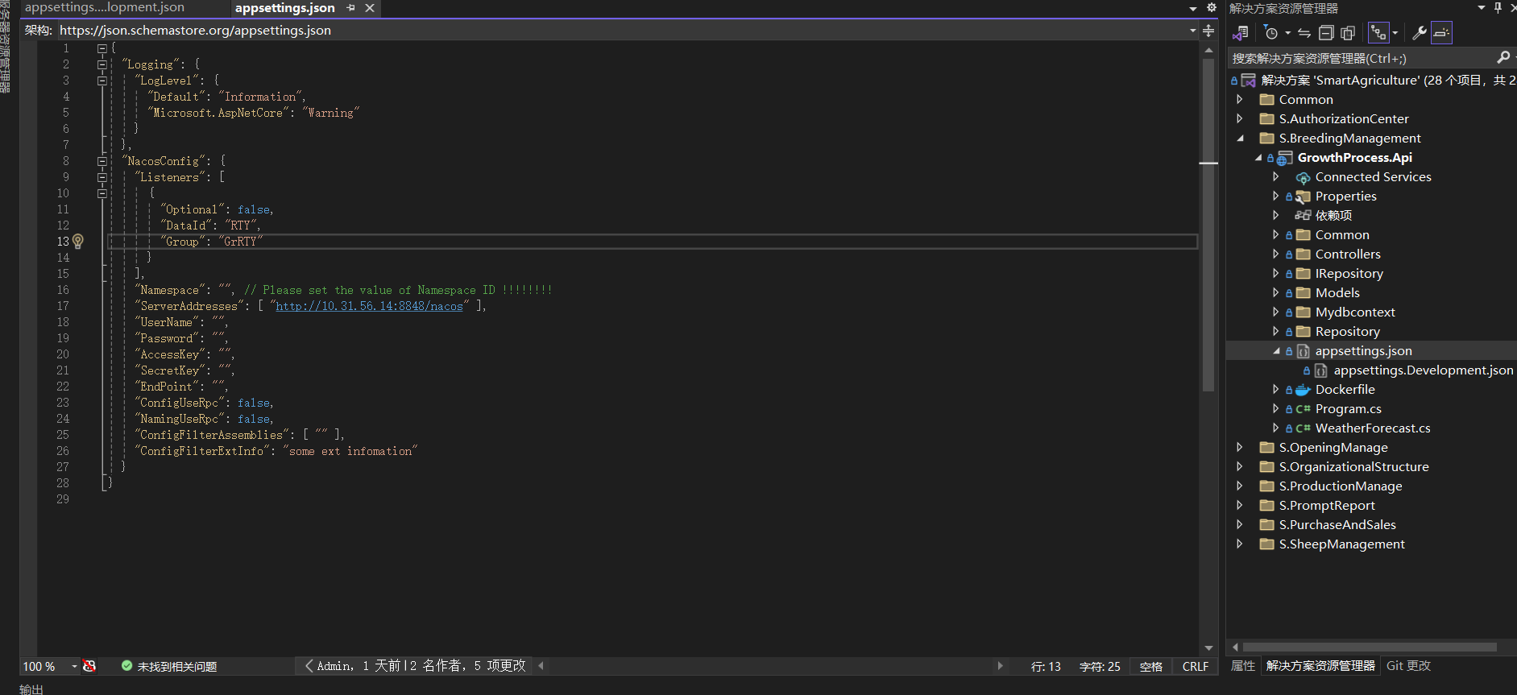
"NacosConfig": {
"Listeners": [
{
"Optional": false,
"DataId": "RTY",
"Group": "GrRTY"
}
],
"Namespace": "", // Please set the value of Namespace ID !!!!!!!!
"ServerAddresses": [ "http://127.0.0.1:8848/" ],
"UserName": "",
"Password": "",
"AccessKey": "",
"SecretKey": "",
"EndPoint": "",
"ConfigUseRpc": false,
"NamingUseRpc": false,
"ConfigFilterAssemblies": [ "" ],
"ConfigFilterExtInfo": "some ext infomation"
}
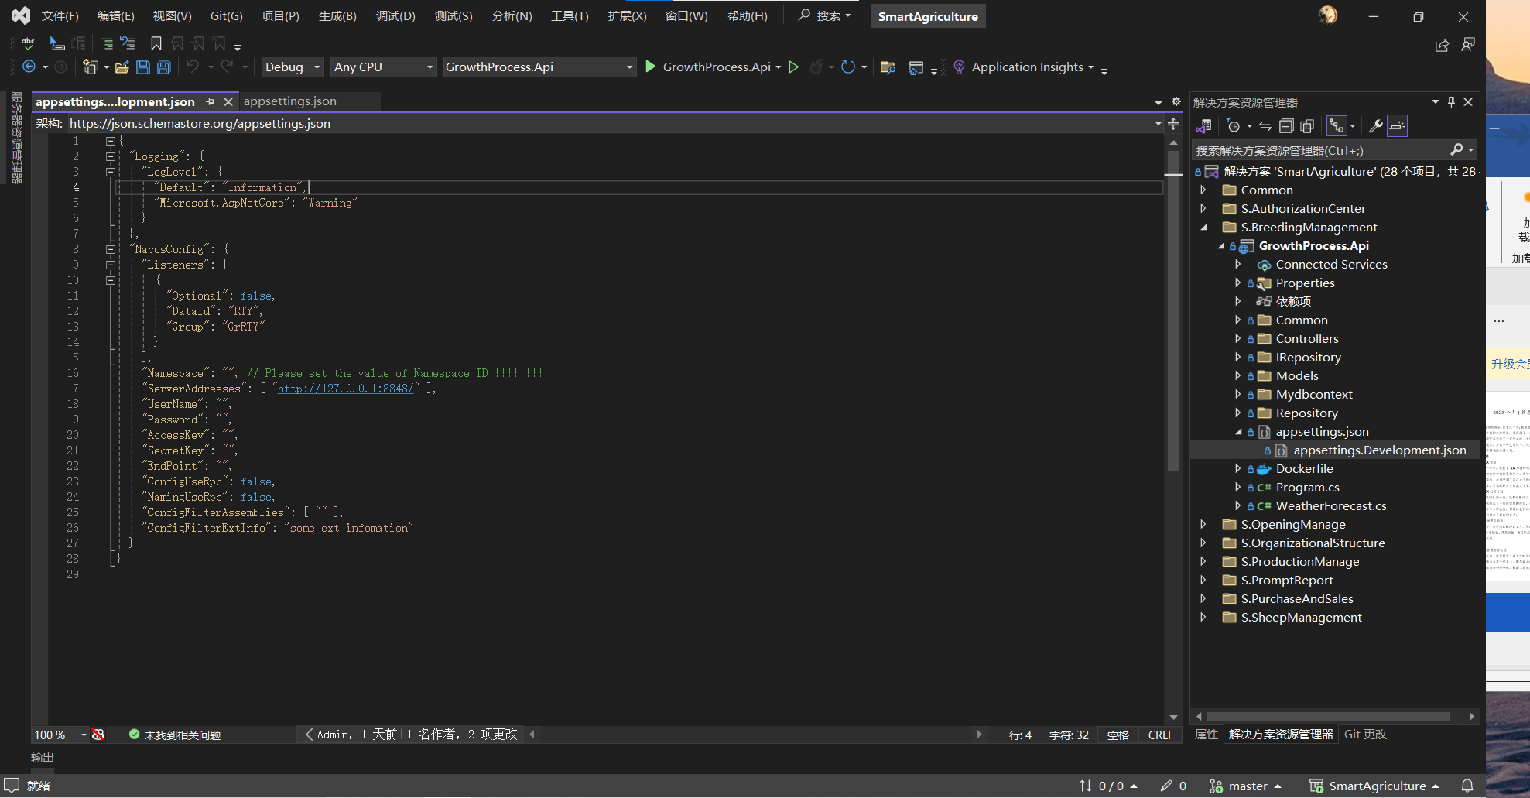

//读取nacos配置
builder.Host.ConfigureAppConfiguration(webBuilder =>
{
webBuilder.AddNacosV2Configuration(webBuilder.Build().GetSection("NacosConfig"));
});

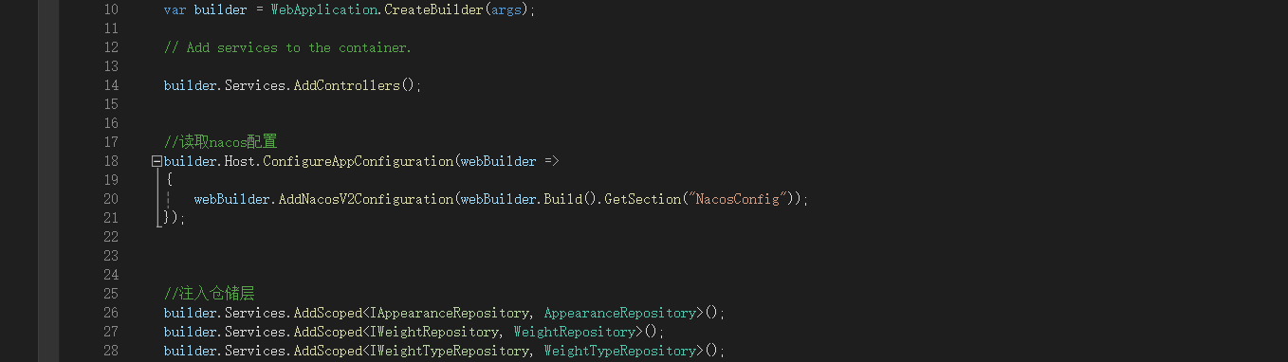

//mysql的连接字符串
builder.Services.AddDbContext<GrowthProcessDbcontext>(opt =>
{
// 从 Nacos 配置中获取ConnectionStrings的ConStr属性
string connectionString = builder.Configuration["ConnectionStrings:Constr"];

//以前读取字符串方式
//string connectionString = builder.Configuration.GetConnectionString("ConStr");
var serverVersion = ServerVersion.AutoDetect(connectionString);
opt.UseMySql(connectionString, serverVersion);
});

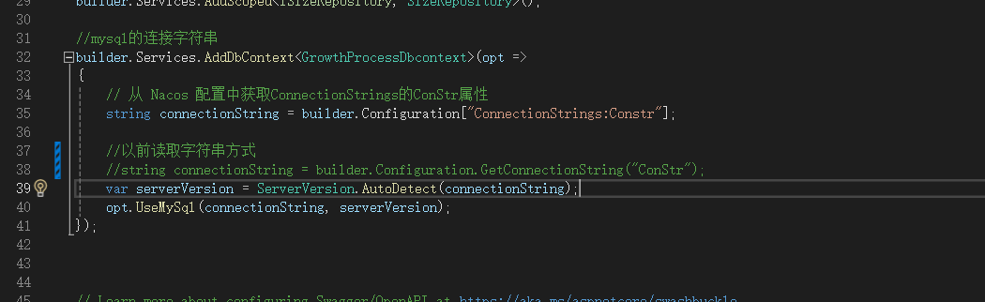

//注册jwt
builder.Services.AddAuthentication(JwtBearerDefaults.AuthenticationScheme)
.AddJwtBearer(options =>
{
//从nacos中读取Authentication 的属性SecretKey（密钥）
string KeysSecretKey = builder.Configuration["Authentication:SecretKey"];
//从nacos中读取Authentication 的属性Issuer（颁发令牌）
string KeysIssuer = builder.Configuration["Authentication:Issuer"];
//从nacos中读取Authentication 的属性Audience（授权）
string KeysAudience = builder.Configuration["Authentication:Audience"];
//取出私钥
var secretByte = Encoding.UTF8.GetBytes(KeysSecretKey);
options.TokenValidationParameters = new TokenValidationParameters()
{
//验证发布者
ValidateIssuer = true,
ValidIssuer = KeysIssuer,
//验证接受者
ValidateAudience = true,
ValidAudience = KeysAudience,
//验证是否过期
ValidateLifetime = true,
//验证私钥
IssuerSigningKey = new SymmetricSecurityKey(secretByte)
};
});

